**Project Requirements Specification**

**Project Name**: Trippin’

**Team Members**  
<Tong Thao>  
<Lauren Nguyen>  
<Lenneth Strikefield>  
<Fahim Murshed>  
<Abdullahi Mohammed>

**Professor**: Ismail Bile Hassan, Information and Computer Science, Metropolitan State University

**Last Updated**: <November 18, 2019>

**Deliverable Number**: <3>

**Document Revision Number**: <4.0>

**Table of Contents**

1. Introduction

b. Vision

1. Scope
2. Business Case
3. Software Architecture Methodology
4. Architectural Goals and Constraints
5. Logical View
   * 1. Client
     2. Admin
6. Use Case
   1. Client
   2. Admin
7. Software Architecture
8. Data Model
9. System Sequence Diagram
   1. Add RideShare Account
10. Sequence Diagram
    1. Client Sequence Diagram
    2. Login Sequence Diagram
    3. Logout Sequence Diagram
11. GRASP Diagrams
    1. Creator
    2. Creator and Information Expert
    3. Adaptor and Polymorphism
12. GoF – Gang of Four
    1. Factory
    2. Strategy
13. **Introduction**
    * 1. In this document we will describe the necessary requirements for the application Trippin’. First, we describe the application vision and scope. Then we will provide more detailed requirements and graphical images to explain out application more in depth.
    1. **Vision:**
       1. The vision is an application that individuals can use that displays the various types of transportation that is in a user’s area. Displaying the information and fare fees allows the user to choose the best method for them to travel. The goal of the application is to encourage more individuals to use different methods of transportation in order to reduce overall congestion of traffic.
    2. **Scope:** 
       1. Our application uses mapping technology in order to display and organize information for the user. From there they can choose the best method of transportation for them. The application can give the information about the type of transportation and the cost of the transportation. In addition, the application has a discount for those who fall into the categories of military veteran, senior citizen or student. Users need to verify that they fall into one of these categories in order to use the discount.
14. **Business Case:**
    * 1. Some business cases for this application is that this application allows users to find the cheapest price for a ride. Not only can they can view the cheapest ride for many different transportation apps all in one place, but this allows users to come back to this application. Therefore, the application may retain a high reputation, and maximize the user’s lifetime use of the application.
15. **Software Architecture Methodology:**
    * 1. An agile methodology will be used in the development of this application. By using the Agile method, we can continue to create a user-oriented application that can continue to grow as our user base grows.
16. **Architectural Goals and Constraints:**
    * 1. Some architectural goals would be the app being able to handle multiple transaction and large amounts of traffic, and all functions of the app must be available and working correctly. A few architectural restrains would be all credit card and financial and user information must be transmitted securely. Lastly, ensuring that a database is secure and consistent in pick up location and times.
17. **Logical View:**
    1. This view contains some of the most important classes and a brief description of each class.
       1. Client:
          1. Contains the information provided by the Client, includes the login, log out, trip information and payment options.
       2. Admin:
          1. Contains classes for content management, profile management and payment management.
18. **Use Case**
19. Client:
    * 1. 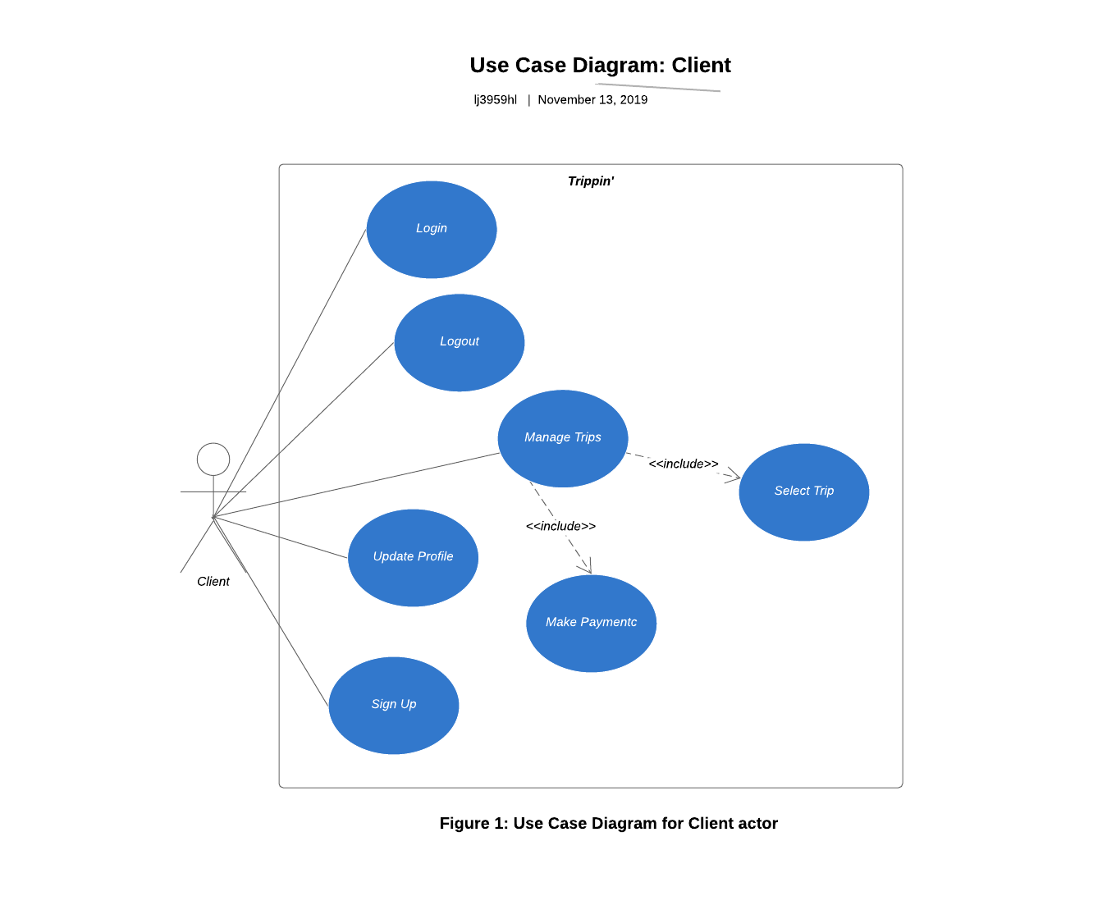
20. Admin:
    * 1. 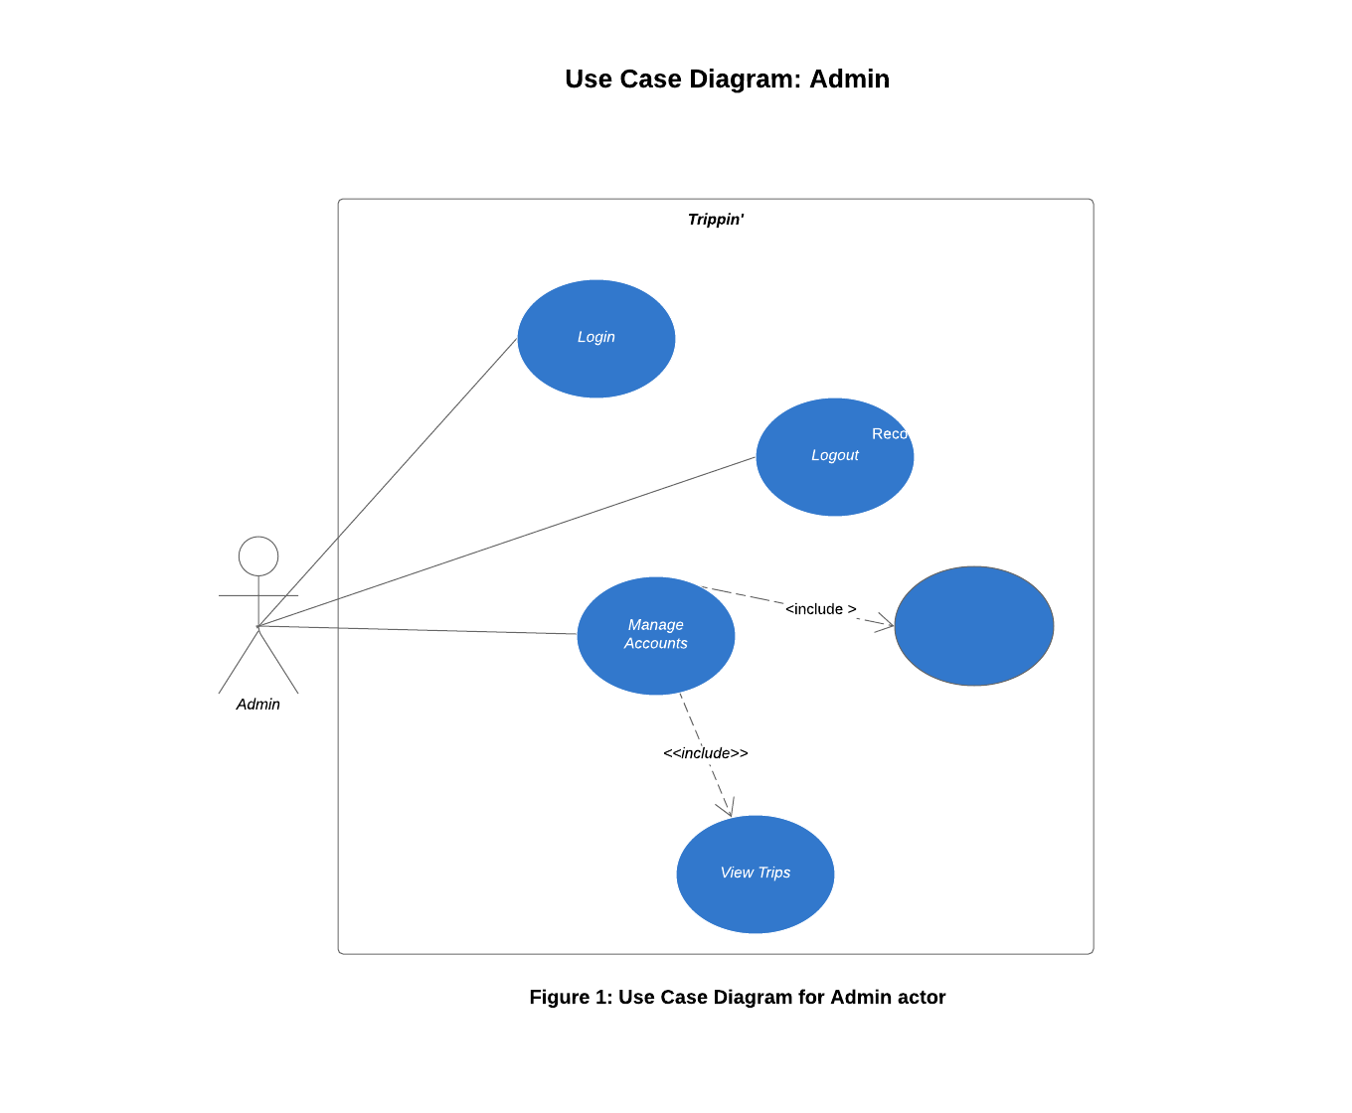
21. **Software Architecture:** 
    * 1. 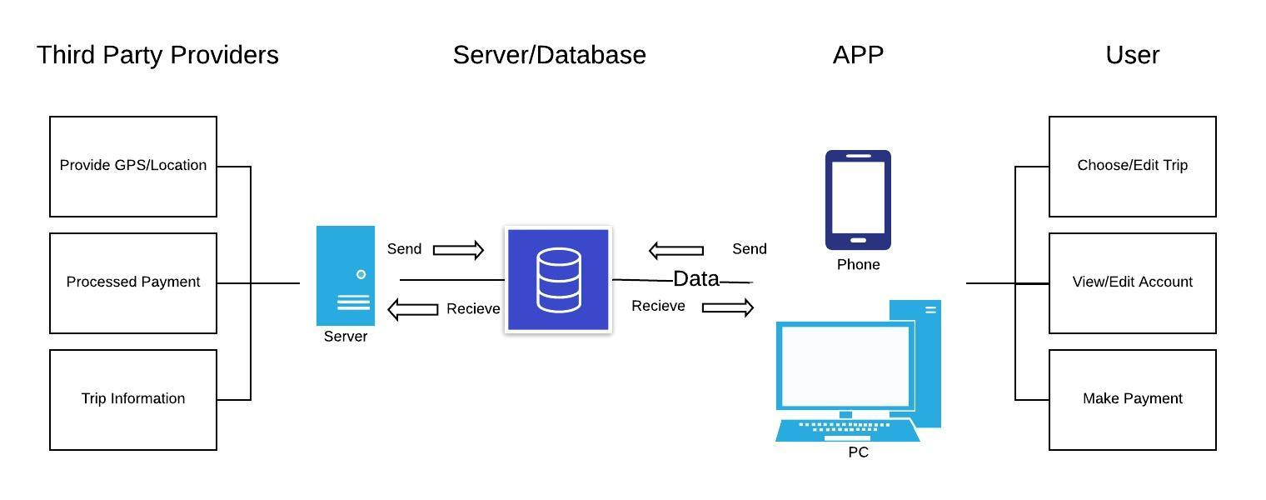
22. **Data Model:**

|  |  |  |
| --- | --- | --- |
| **Class** | **Attributes** | **Data Type** |
| Client | ID  Name  Phone Number  Email | Int  String  Int  Varchar (30) |
| Administrator | Username  Password | Varchar (10)  Varchar (30) |
| Account | Username  Password  ID | Varchar (10)  Varchar (30)  Int |

1. **System Sequence Diagram:**
   1. Add RideShare Account:
      1. 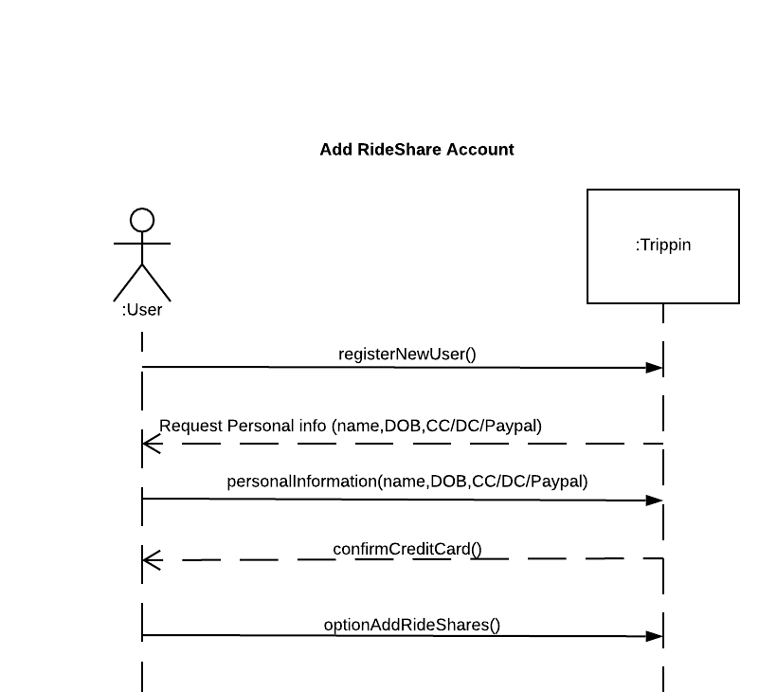
2. **Sequence Diagram:**
   1. Client Sequence Diagram
      1. 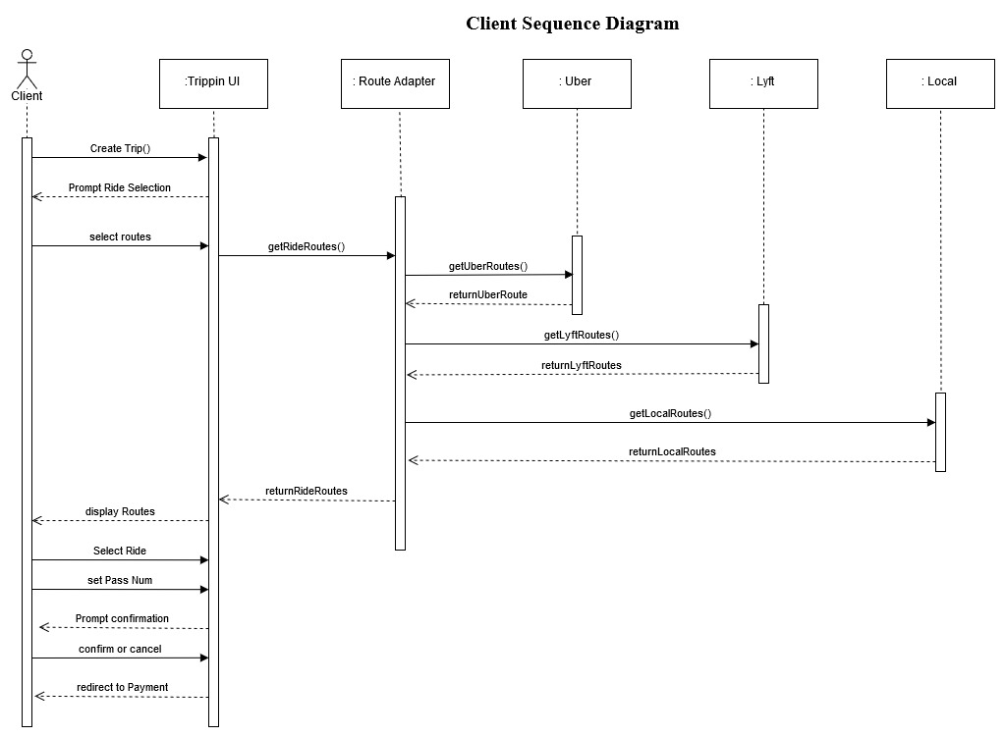
   2. Login Sequence Diagram:
      1. 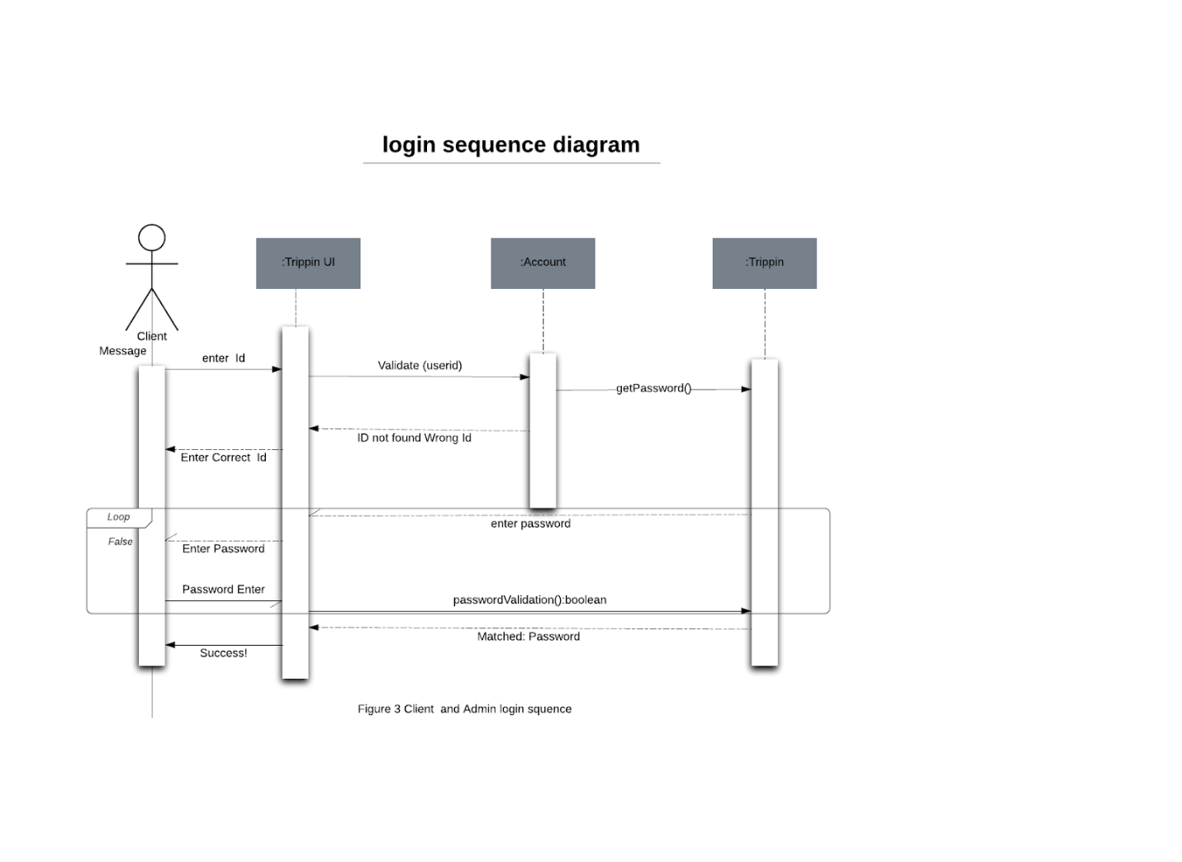
   3. Logout Sequence Diagram:
      1. 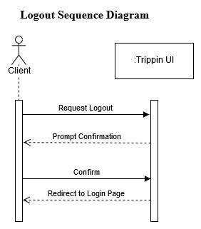
3. **GRASP Diagrams:**
   1. Creator:
      1. 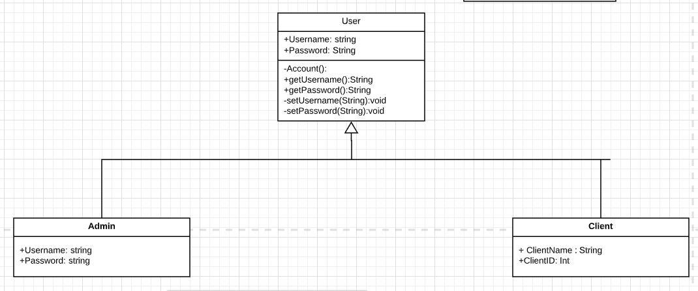
   2. Creator and Information Expert:

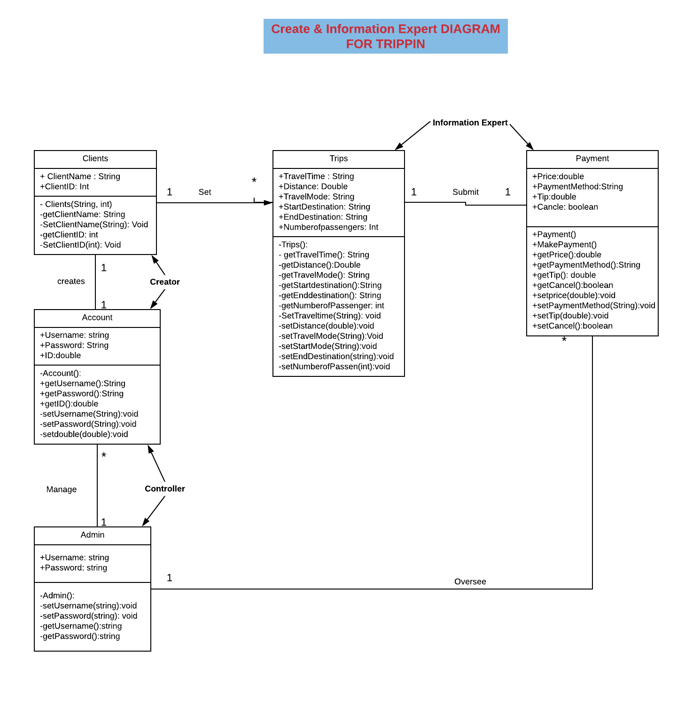

* 1. Adaptor and Polymorphism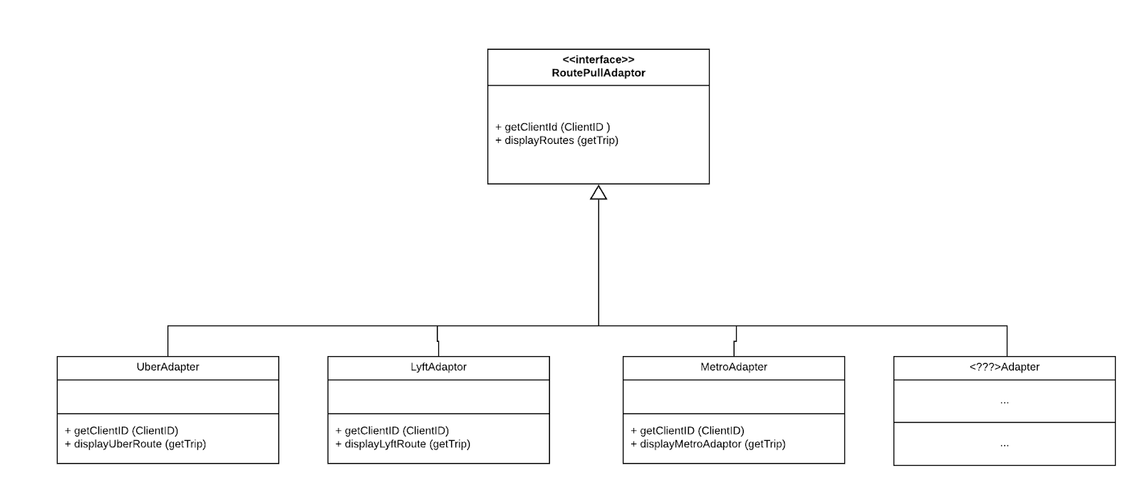

1. **GoF – Gang of Four**
   1. Factory:
      1. 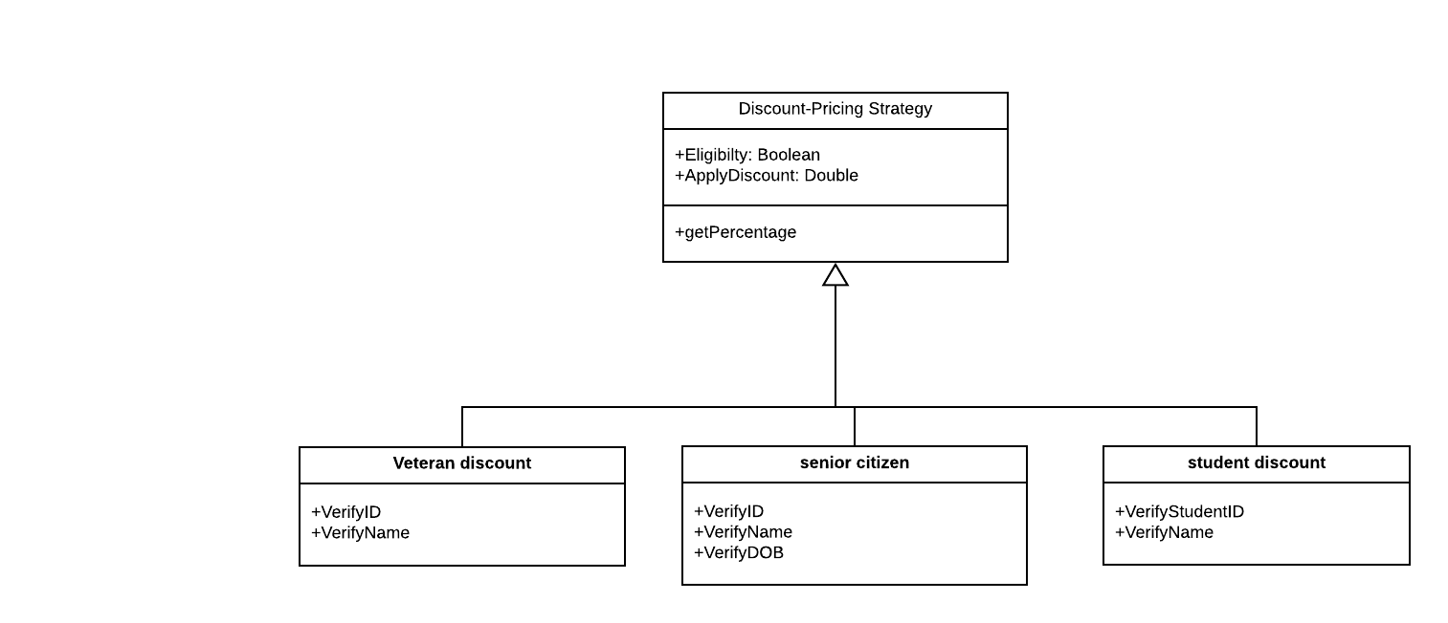
   2. Strategy:
      1. 